Installation:
- Download the latest release from link https://www.mongodb.com/try/download/community
- In the mongodb official site click on PRODUCTS then
- Click on MONGODB COMMUNITY SEVER
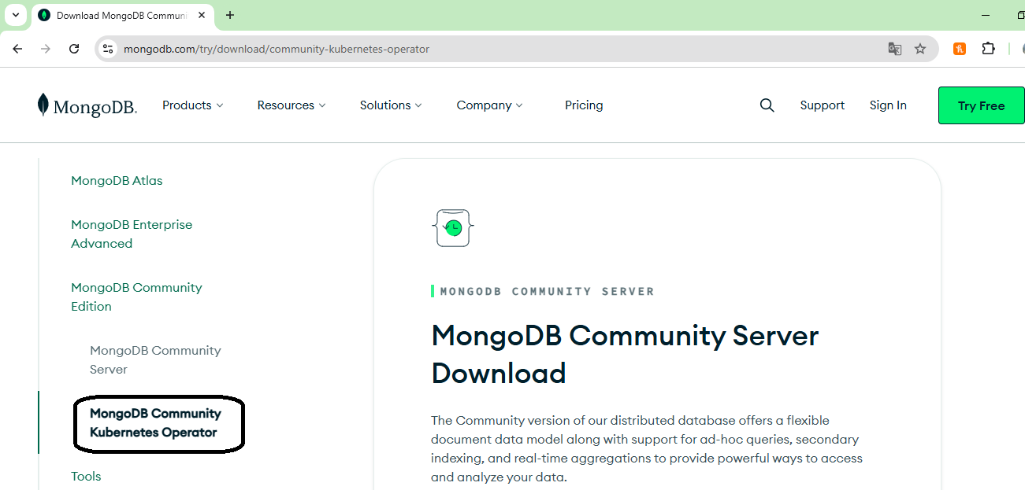
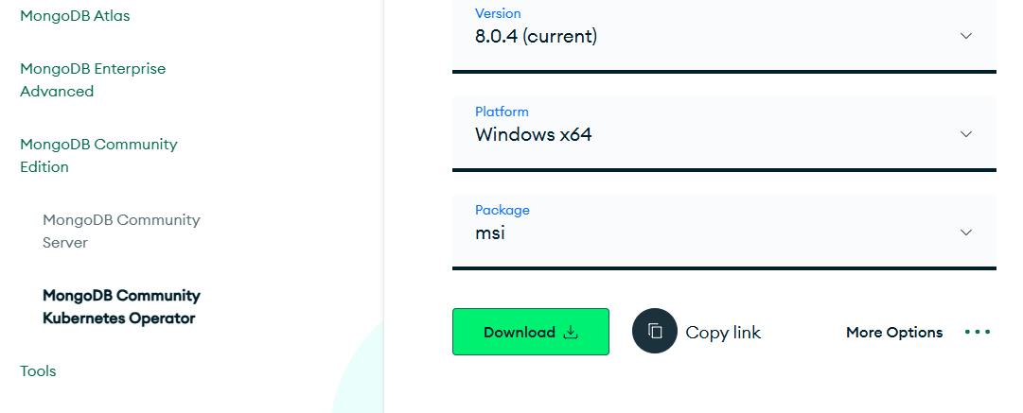
- Make sure that you are downloading the appropriate file, specially check whether your operating system type is 32-bit or 64-bit.
- Click on Download button.
After down loading the MangoDB setup file , double click on it.
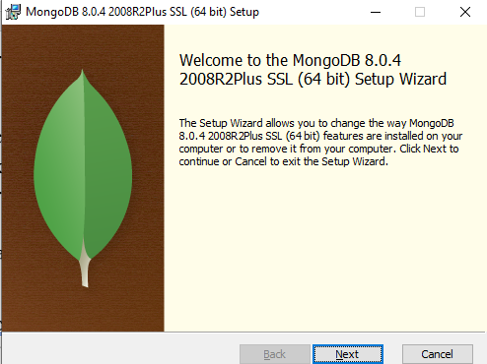
Click on Next
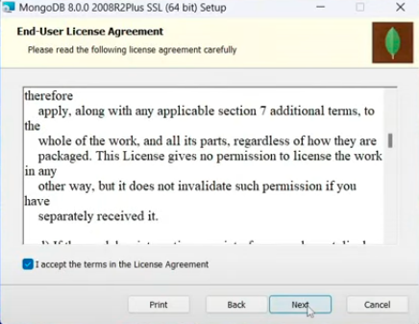
Accept the terms and conditions in the Licence Aggriment , Click on Next
In the Choose Setup Type window :
Select Complete Setup Type and Click on Next button
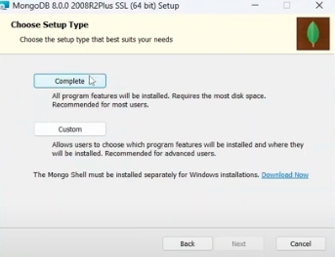
- In the Service Configuration page:
Select Run service as a Service user
Service name : MangoDB
Data Directory : C:\ Program Files\ MangoDB\Server|8.0\data\
Log Directory : C:\ Program Files\ MangoDB\Server|8.0\log\
Click on Next
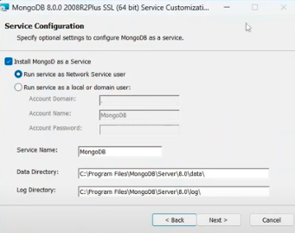
- In MongoDb Campass
- 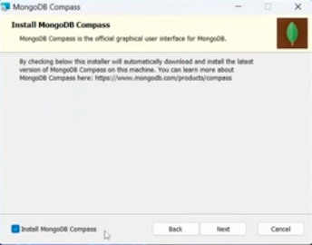.
- In a few minutes it displays MongoDB installed
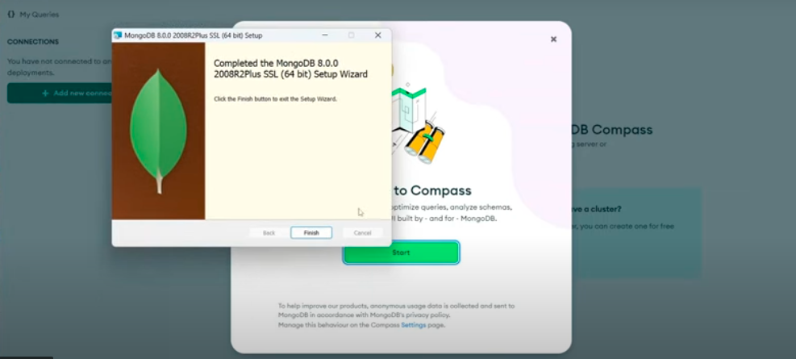
- After installation click on Finish.
- Click on Start
- It displays MongoDB starting screen .
- Click on Add New Connections
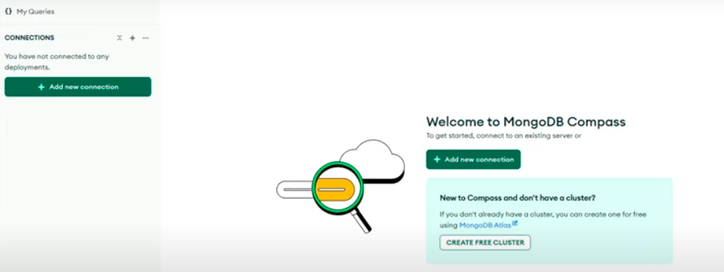

It displays New Connection window. Click on Connect.

To create a new data base click on Create database . It on Right Top of the screen. Or click on + button.

Enter the
Database Name :
Collection Name:
Click on create Database.

You can see the data base in the databases list.
- - - - - - - - - - - - - - - - - - - - - - - - - - - - - - - - - - - - - - - -

Installation Proce of Mongo Shell:

Below the community server click on TOOLS
Click on MongoDBShell

Version : 2.3.8
Platform : Windows X64
Package : msi
Click on Download
(It displays Welcome to MongoDB Shell window) click on NEXT
( It displays Default local window ) click on NEXT
Click on FINISH

MongoDBShell installation completed.

From START menu open COMMAND PROMPT
At the prompt type mongosh
C:\Users> mongosh

